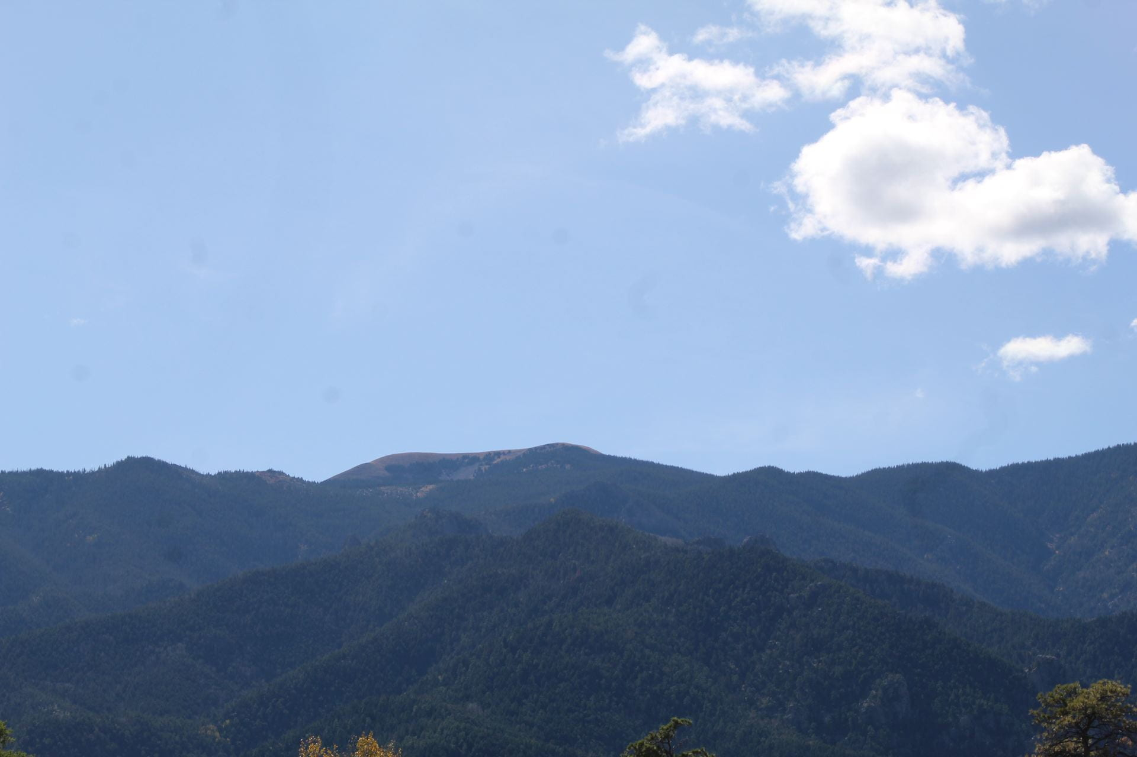
Photo by: Caity
I really like the details in this photo, I especially enjoy the wide, blue sky
.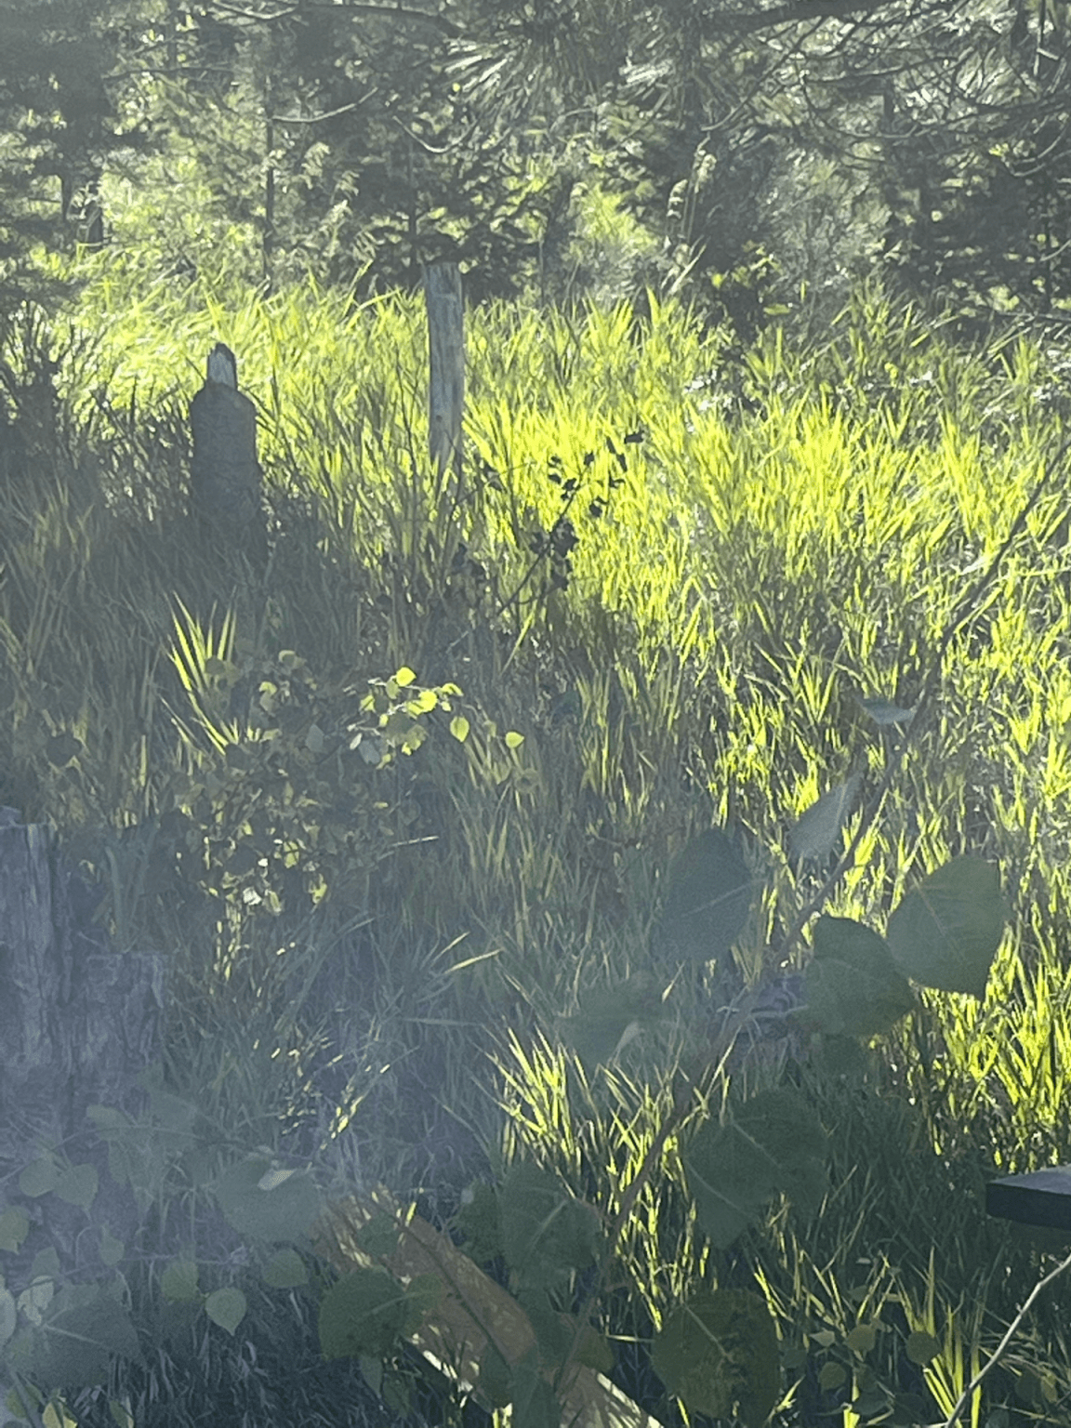
Photo by: Josie
This image is very enjoyable to look at because of the way the light hits the green grass and all the shadows add contrast.
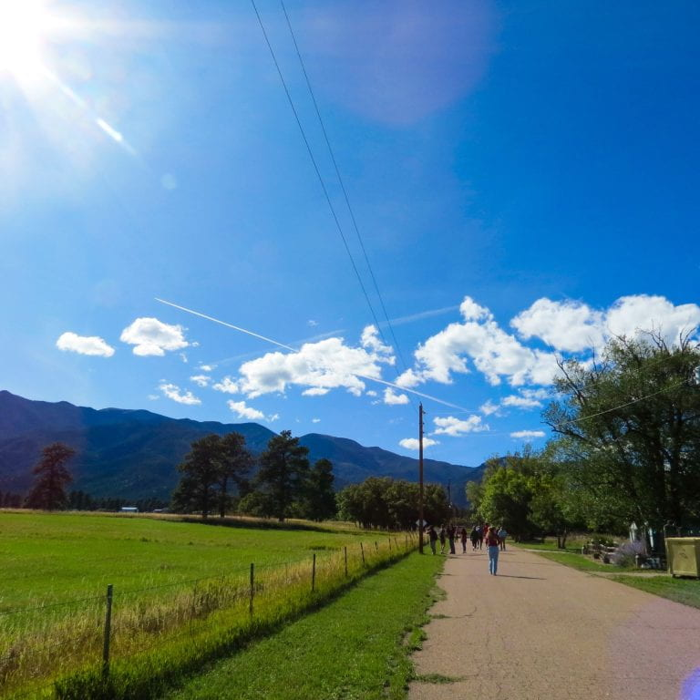
Photo by: Kaitlyn
This photo is very vibrant and colorful which adds to the coolness of this image.
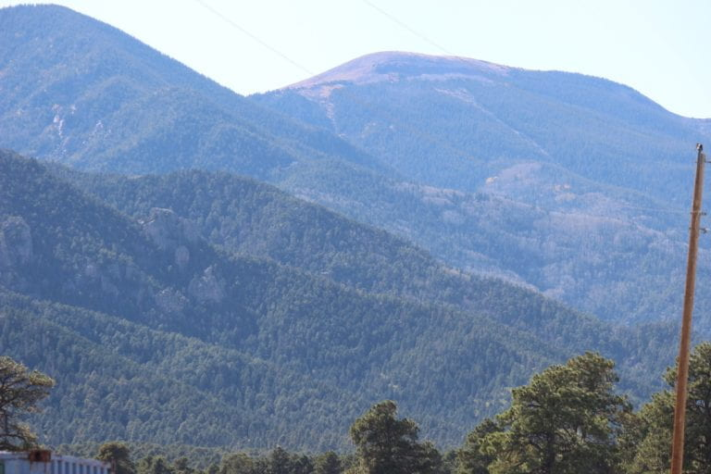
Photo by: Ava
This photo is just great! you can really see the mountain from a far away distance.

