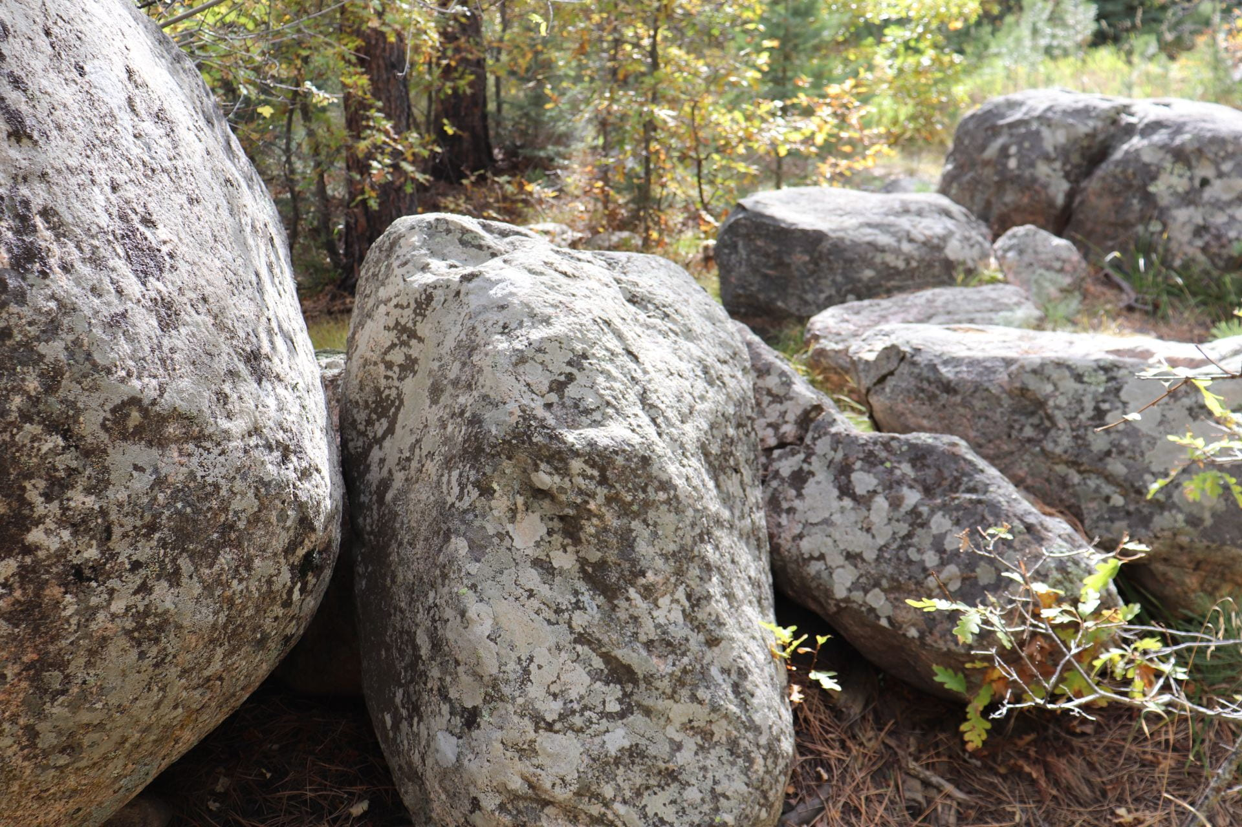
Photo By: Blake
Wow! You can really see the texture of the rocks! The rocks and the background trees look really good together.
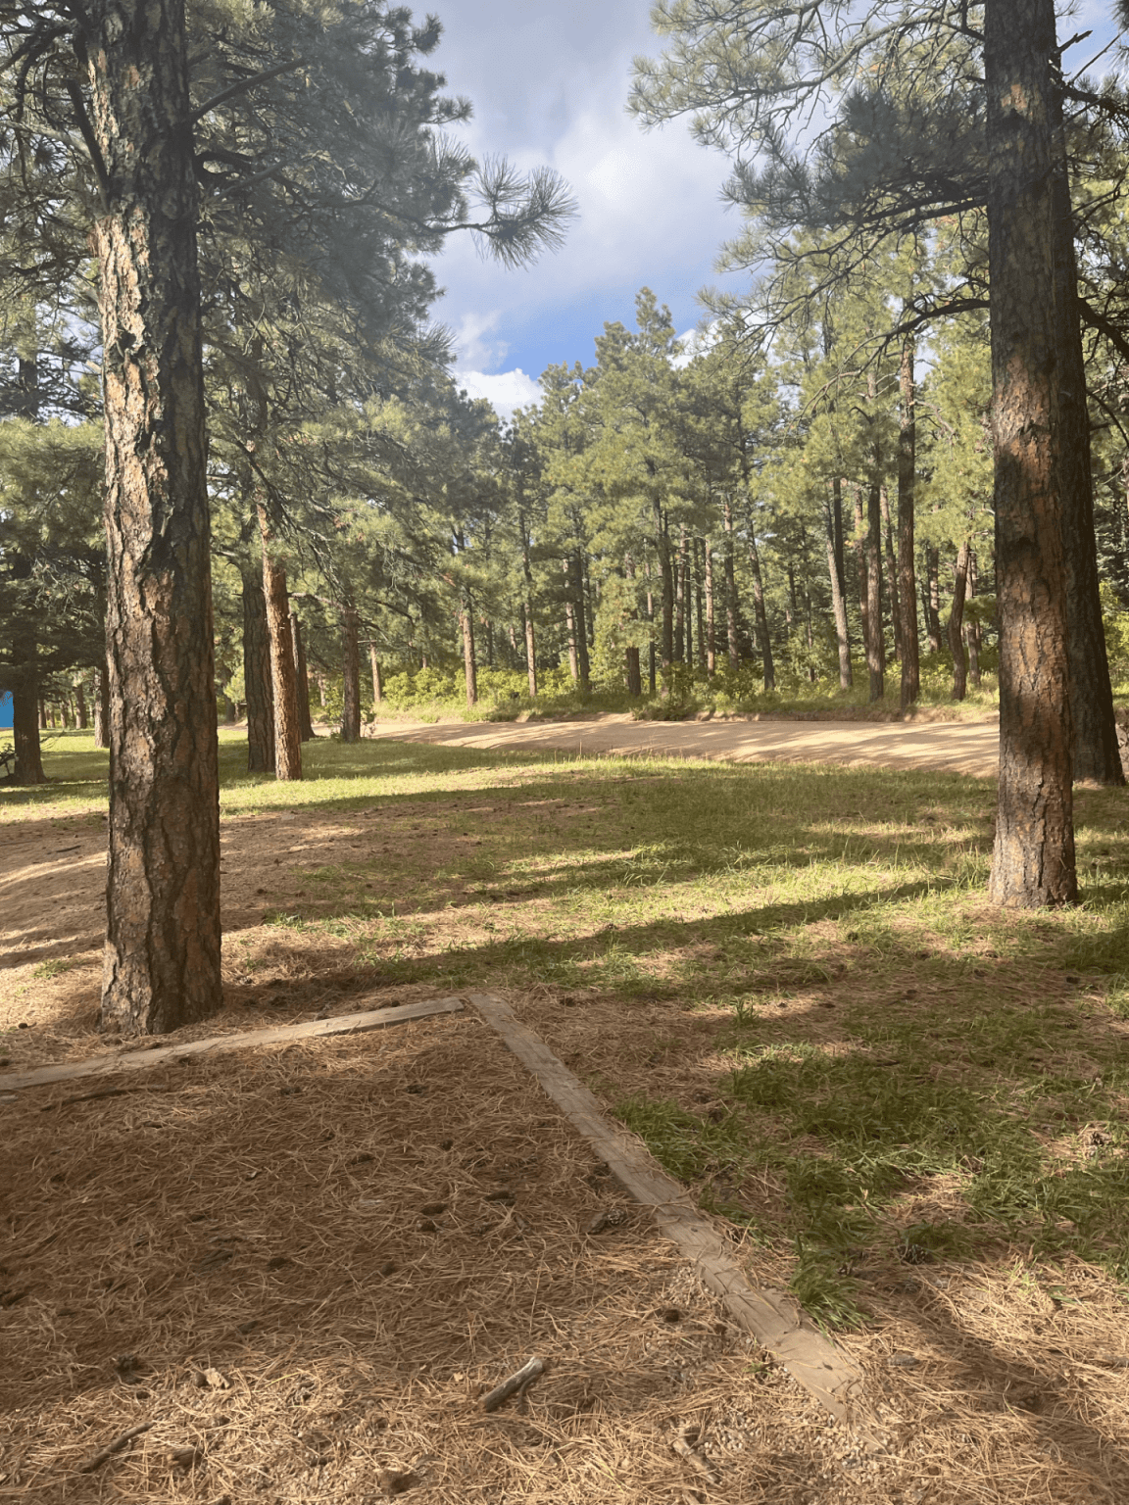
Photo By: Josie
I really love the lighting. The composition and camera angle is heavenly, The distance between the trees and the camera angle you took it in really adds to the photo.

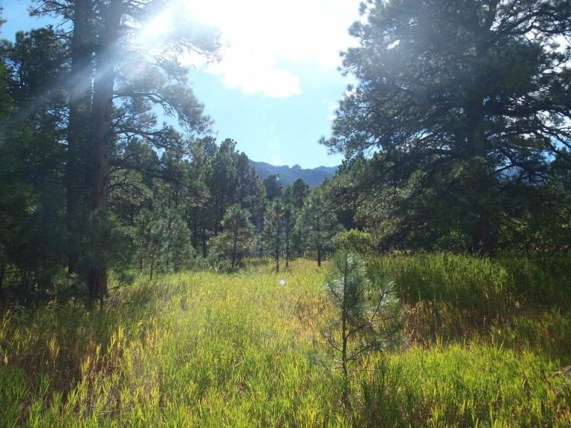
Photo By: Eli
I truly love the lighting, the way the sunshine hits the beautiful green grass makes the image look more natural.
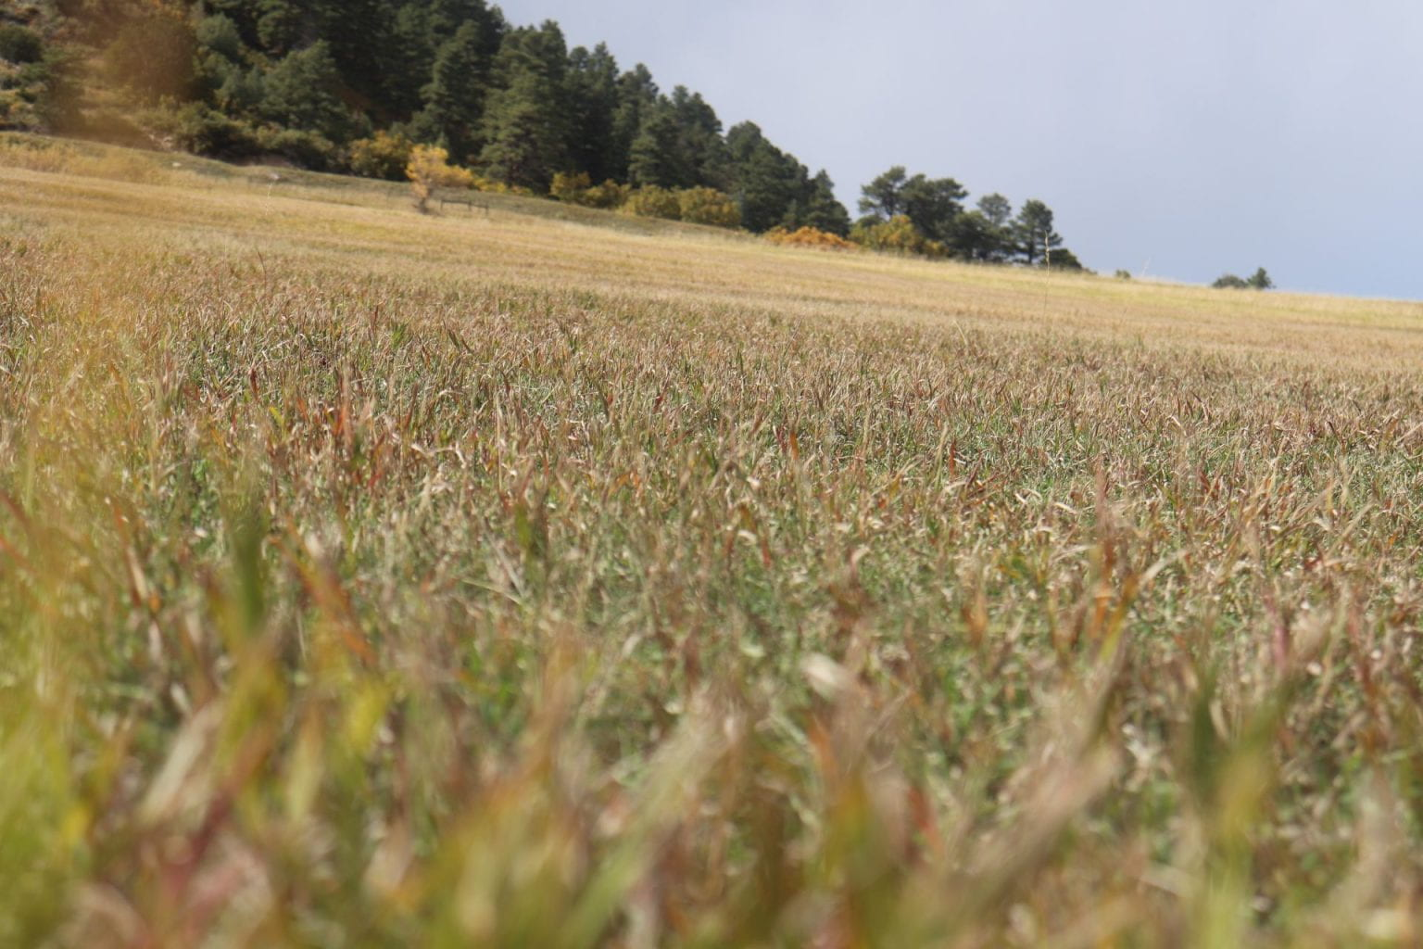
Photo By: Oliver
Nice picture, I really like the camera angle, it makes the photo look more interesting.

